100 West 10th Street, Suite 500
Wilmington, DE 19801
philanthropydelaware.org
info@philanthropydelaware.org 302-588-1342
November x 2022

Board of Directors

Chris Crothers
(President)
Jessie Ball duPont Fund

Amy Walls
(Vice-President)
Discover Bank

Vernita Dorsey
(Immediate Past President)
WSFS Bank

Michelle A. Taylor
(Secretary)
United Way of Delaware

Todd Veale
(Treasurer)
Laffey-McHugh Foundation

Ashley Cook
Wells Fargo

Sharon Struthers
Struthers Family Foundation

(insert full address)

Dear XXXX,
We continue to value (insert organization) and you, for the ongoing support and partnership in the work of Philanthropy Delaware as we continue to demonstrate the value of philanthropy in the first state.
The philanthropic community persevered on behalf of our neighbors by supporting many efforts in response to the ongoing needs of our neighbors and leveraged new opportunities to demonstrate the important role of the sector.
The support of our Members allows Philanthropy Delaware to continue offering opportunities to collaborate, access research and data, learn about the various areas of need in order to make informed, impactful and sustainable funding decisions.
Please note that it has become necessary to increase our dues for 2023; something we have not done since 2020. We ask that you check the previous fiscal year annual giving/grantmaking in Delaware for your organization to ensure that the attached invoice accurately reflects your membership dues for the new year. A guide is included.
As you continue your level of support by renewing your membership, we remind you that there are opportunities to increase your support and become a Sustainer Partner by doubling your dues, sponsoring an event or program, or providing general operating support. We will be happy to meet with you to walk through our Menu of Opportunities to help determine the most appropriate selection for support.
If you have any questions about the renewal process, please reach out to me via phone or at tynetta@philanthropydelaware.org.
We look forward to continuing to work with you in 2023 and creating an even stronger philanthropic community that will enhance the lives of all our Delaware communities.
In the spirit of philanthropy,
Tynetta T. Brown
President and CEO

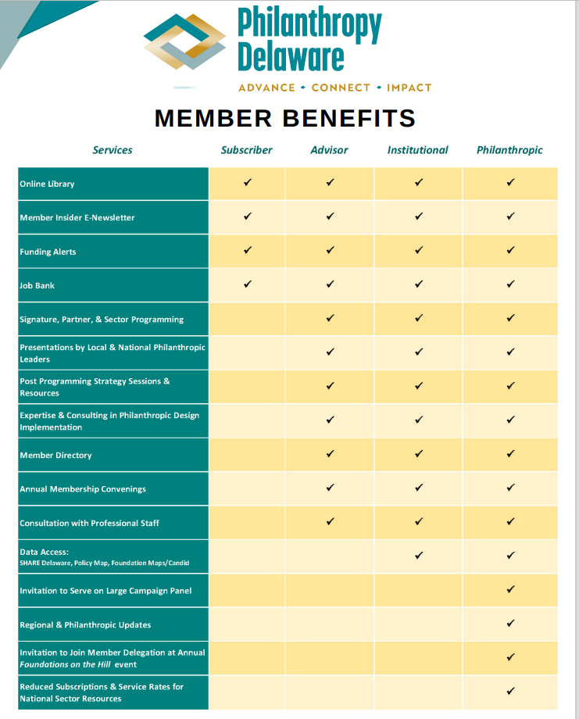

Philanthropy Delaware – Member Discounts
Members receive reduced registration rates and special sponsorship advantages for Philanthropy Delaware Signature Programs, special events, and some partner and sector programming.
Philanthropy Delaware is a member of the United Philanthropy Forum, which provides discount opportunities on a variety of sector related services for Philanthropy Delaware members. For a full list, see below.
- Alliance Magazine – Members are eligible to receive a 20% discount on new print and digital subscriptions to this magazine for philanthropy and social investment worldwide providing news and analysis of what’s happening in the sector.

- The Chronicle of Philanthropy - Provides foundation executives, board members, nonprofit professionals, and others with the indispensable information and practical advice. Members are eligible to receive a 10% discount on a site license.

- ClickTime - Track employee time against the programs and grants you manage, ensure compliance, drive increased funding, and manage expenses with ClickTime, which provides online time tracking and expense reporting free for Forum member organizations and discounted for your members.

- Foundation Legal Help Desk - The Help Desk is designed to provide foundations with access to answers to legal questions related to the operations of a foundation.

- Inside Philanthropy - Get a discount of 25% off the subscription price for new subscriptions for you and your members. Every day, Inside Philanthropy editors and journalists seek to bring more transparency and accountability to philanthropy at a time that it's having a growing impact on America and the world through their reporting.

- Stanford Social Innovation Review - For a discounted price you and your members can subscribe to Stanford Social Innovation Review (SSIR), whose mission is to advance, educate, and inspire the field of social innovation by seeking out, cultivating, and disseminating the best in research- and practice-based knowledge.

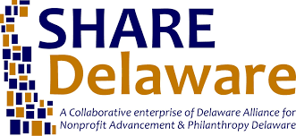
Member Resources
_________________________________
SHARE Delaware, Delaware’s first comprehensive and searchable resource database map that shows nonprofits and their programs. Transforming the Delaware nonprofit and philanthropic community through universally accessible and useful information for the purpose of inspiring collaboration and driving sustainable impact. This tool available for Philanthropy Delaware members allows you to see which organizations are providing specific services to demographics. All registered 501(c)3 organizations operating in the State of Delaware are available at your fingertips.
___________________________
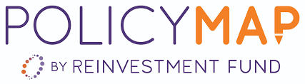
The web’s largest place-based data library with simple mapping and reporting tools. Philanthropy Delaware’s partnership with Policy Map gives us the ability to create and share compelling maps, download data, compare data across locations, generate on-the-fly reports, run analytics, and upload your select data. We have access to tens of thousands of indicators from hundreds of authoritative sources. Policy Map data includes demographics, real estate, health, jobs, and more from sources like the Census, the Department of Housing and Urban Development, CDFI and GreatSchools. Policy Map is a data and mapping tool for accessing data about communities across the nation and on a local level to make better-informed decisions.
_____________________________________________
The “Get on the Map” campaign – a partnership of the United Philanthropy Forum and Candid is a data-sharing initiative dedicated to boosting the quality and availability of fresh, detailed grantmaking data access across the network. The Foundations Maps tool is available to get complete and up-to-date answers to such questions as Who else is funding a particular issue in our region? What organizations are tackling that issue? Where are the funding gaps? Who may be natural collaborators? Who is funding for potential match dollars for other funding?

For more Information: Contact us at 302-588-1342 or by email info@PhilanthropyDelaware.org

2023 Membership Form
**Notes in “red” will be removed.
*** Sustainer Grants in 2022 from M&T, Wells Fargo -Briggs, Jesse Ball duPont; Welfare, WSFS, Corteva

Membership Level | 2022 Annual Giving | 2023 Dues | 2022/2021/2020 | # of Members
Philanthropic | Less than $100,000 | $ 550 | $ 550 | 7
21% increase | $ 100,001 - $250,000 | $ 1,000 | $ 825 | 6
36% increase | $ 250,001 - $500,000 | $ 1,400 | $1,100 | 4
21% increase | $ 500,001 - $1 Million | $ 2,000 | $1,650 | 9
27% increase | $1,000,001 - $2 Million | $ 3,500 | $2,750 | 2
* 18% increase | $2,000,001 - $5 Million | $ 6,500 | $5,500 | 9
0% increase | More than $5 Million | $11,000 | $11,000 | 1
Institutional | 27% increase | $1,400 | $1,100 | 4
Advisor:
Full Firm | 25% increase | $1,250 | $ 900 | 3
Independent | 0% increase | $ 500 | $ 500 | 1
Subscriber | 0% increase | $ 400 | $ 400 | 6

Please calculate Member Dues based on your organizations annual giving in Delaware during fiscal year 2022.
Calculation:
Membership Dues | $
Sustainer Support | $
Total | $

Please check the applicable option:
□ Yes, we want to renew our Philanthropy Delaware membership and will make our payment in the amount of the Total above online at: Philanthropy Delaware - Donate

□ Yes, we want to renew our Philanthropy Delaware membership and have enclosed a check for the Total above.

□ Yes, we are interested in a conversation about the Menu of Opportunities to further support and engage with Philanthropy Delaware. Please contact me for a meeting to discuss.

□ Yes, we want to renew our Philanthropy Delaware membership, please invoice us for the amount noted in the Total above and we will process a check or send via ACH payment if banking information is on file.

□ No, we do not plan to renew our Philanthropy Delaware membership because ____________________________________________________________________________

Contact:
We, ____________________________________, pledge to renew our 2023 membership in the
amount of $__________. Payment will be made on __________________.
Signature of Organization Representative: ______________________________
Printed Name: ____________________________________________________
Title: ____________________________________________________________
Email: ___________________________________________________________
Date: _______________________

Please return your completed form and payment to:
Attn: Membership and Programs
Philanthropy Delaware, Inc.
100 W. 10th St., Suite 500
Wilmington, DE 19801
Federal Tax ID#: 27-2529635

All information provided is confidential.

